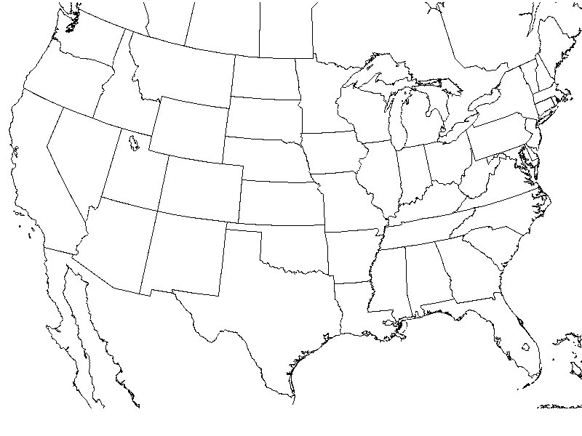
*Tulsa
*Tucsan
*Nashville
*Pensacola
*Atlanta
*Boston
*New York City

C
*Charlotte
*Cleveland
*Chicago
*Minneapolis
*Dallas
*Wichita
*Denver
*Billings
*Seattle
*Los Angeles
*Las Vegas
- Draw a warm front from the southwest direction heading from Dallas, Texas towards Chicago, Illinois.
- Draw a cold front from the northwest direction from Seattle, Washington to Denver, Colorado.
- Draw a stationary front over the New England states such as Boston and New York.
- Draw a low pressure system over Cleveland, Ohio.
- Draw a high pressure system over Las Vegas, Nevada.
Based on the fronts you have just created, answer the following questions:
- What type of weather would Chicago, Illinois have in the next 24 hours?
___________________________________________________________________________

- What city could be experiencing thunderstorms in the 48 hours? ___________________

- Which city is experiencing clear, blue skies and fair weather? ______________________

- Which city is experiencing stormy weather? ____________________________________

- What type of weather would Denver, Colorado have in the next 24 hours? ________________________________________________________________________

