Name_________________ Period ____
Endocrine System Webquest
Visit the following sites to answer the questions below.
Site # 1 - What Is the Endocrine System?
http://kidshealth.org/teen/your_body/body_basics/endocrine.html
Questions
- What are the functions of the endocrine system? _____________________________________________________________________________________________________________________________________________________________________________________________________________________
- What are hormones and what is their function?
_______________________________________________________________________ _______________________________________________________________________ _______________________________________________________________________
- Which factors affect hormone levels in your blood? ______________________________________________________________________________________________________________________________________________
_______________________________________________________________________
- What is a gland? Give an example. _____________________________________________________________________________________________________________________________________________________________________________________________________________________
- How are exocrine glands different than endocrine glands? _____________________________________________________________________________________________________________________________________________________________________________________________________________________
- List the major glands/organs that make up the endocrine system. _______________________________________________________________________
_______________________________________________________________________
_______________________________________________________________________

Site # 2 – Parts of the Endocrine System
http://kidshealth.org/parent/general/body_basics/endocrine.html# Page 2
- Label the major parts of the Endocrine System below
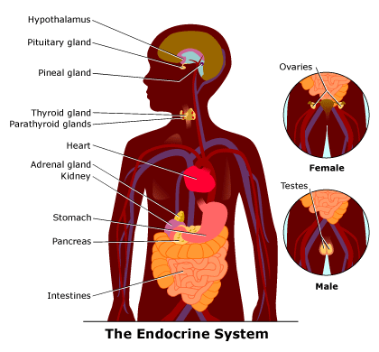

Site # 3 – Gland Specifics – Structure and Function http://kidshealth.org/parent/general/body_basics/endocrine.html#
Questions:
- The ____________________________________________, a collection of specialized cells that is located in the lower central part of the brain, is the primary link between the endocrine and nervous systems. Explain how this works. _______________________________________________________________________
_______________________________________________________________________
_______________________________________________________________________
- Which gland is called the “master gland”? Explain why it is given this name. _______________________________________________________________________
_______________________________________________________________________
_______________________________________________________________________
- List the hormones (and their jobs) that are produced by the pituitary gland:
a. Anterior Lobe:
_______________________________________________________________________
_______________________________________________________________________ _______________________________________________________________________
_______________________________________________________________________
_______________________________________________________________________
_______________________________________________________________________
b. Posterior Lobe:
_______________________________________________________________________
_______________________________________________________________________
_______________________________________________________________________
- What are thyroid hormones responsible for? _______________________________________________________________________
_______________________________________________________________________
_______________________________________________________________________
- What do parathyroids regulate in the blood? _______________________________________________________________________
_______________________________________________________________________
_______________________________________________________________________
- Where are adrenal glands located in the body? _______________________________________________________________________
_______________________________________________________________________
_______________________________________________________________________

Site # 4 – Test Yourself: Use the info in this page to complete the chart.
Hint - Use the Drag and Drop Matching at the bottom of the page to aid you in your quest.
http://www.abpischools.org.uk/page/modules/hormones/horm2.cfm?coSiteNavigation_allTopic=1
- Contrast the 2 parts of the adrenal glands:
Endocrine Gland | Where in the body | Hormone produced
Pituitary
Testis
Ovary
Pancreas
Adrenal
Thyroid

- Differentiate between the female and male gonads. List their functions, locations and which hormones they produce.
Female | Male

- Which endocrine gland starts off the process of puberty? ________________________
- Which two hormones, produced by this gland, stimulate the production of sex hormones? _____________________________________________________________
- What hormone is produced in the testes? ____________________________________

Site # 5 – Gland Specifics – Structure and Function http://kidshealth.org/parent/general/body_basics/endocrine.html#
- What are the 2 major hormones produced by the pancreas? What are their roles in the body? _________________________________________________________________
- _______________________________________________________________________
_______________________________________________________________________
_______________________________________________________________________
- Once a hormone is secreted, how does it get to its target cells? _______________________________________________________________________
_______________________________________________________________________
_______________________________________________________________________Endocrine Disorders: Give definition, treatment/prevention, etc. for each
- AdrenalInsufficiency: ___________________________________________________
_______________________________________________________________________
_______________________________________________________________________
- Cushing Syndrome: ____________________________________________________
_______________________________________________________________________
_______________________________________________________________________
- Type I Diabetes: _______________________________________________________
_______________________________________________________________________
_______________________________________________________________________
- Type II Diabetes: ______________________________________________________
_______________________________________________________________________
_______________________________________________________________________
- Growth Hormone abnormalities: _________________________________________
_______________________________________________________________________
_______________________________________________________________________
- Hyperthyroidism: ______________________________________________________
_______________________________________________________________________
_______________________________________________________________________
- Hypothyroidism: _______________________________________________________
_______________________________________________________________________
_______________________________________________________________________

