Photosynthesis Guided Notes
Cells Need Energy
- To stay alive, cells need a constant supply of energy. Animals get energy from food, while plant cells get energy from ______________.
- Chemical energy- energy stored in the _______________ between atoms of every molecule
- A major energy source for most cells is stored in a sugar molecule called ______________.
Why do we need energy?
- When you need energy, cells release chemical energy from ___________.
- When you move, muscle cells release chemical energy from glucose (_________________) to move your legs.
- The more you move, the more glucose your muscle cells need. You eat food to restore the glucose supply in muscles. (Remember, glucose is __________!)
- Plants transform the energy in sunlight into the chemical energy in glucose in their ______________.
- _________________- The process that plant cells use to change the energy from sunlight into nutrients for the plant.
- The source of energy for all organisms ultimately comes from the Sun.
- Takes place in the _________________ of plant cells.
- Chloroplasts contain _______________ which traps the sunlight.
How does photosynthesis work?
1. The starting materials: _______________ and ________________
2. The process: Carbon dioxide and water enter the plant cell’s _______________. Meanwhile, __________________ is capturing energy from the sun.
3. The products: Glucose and _______________.
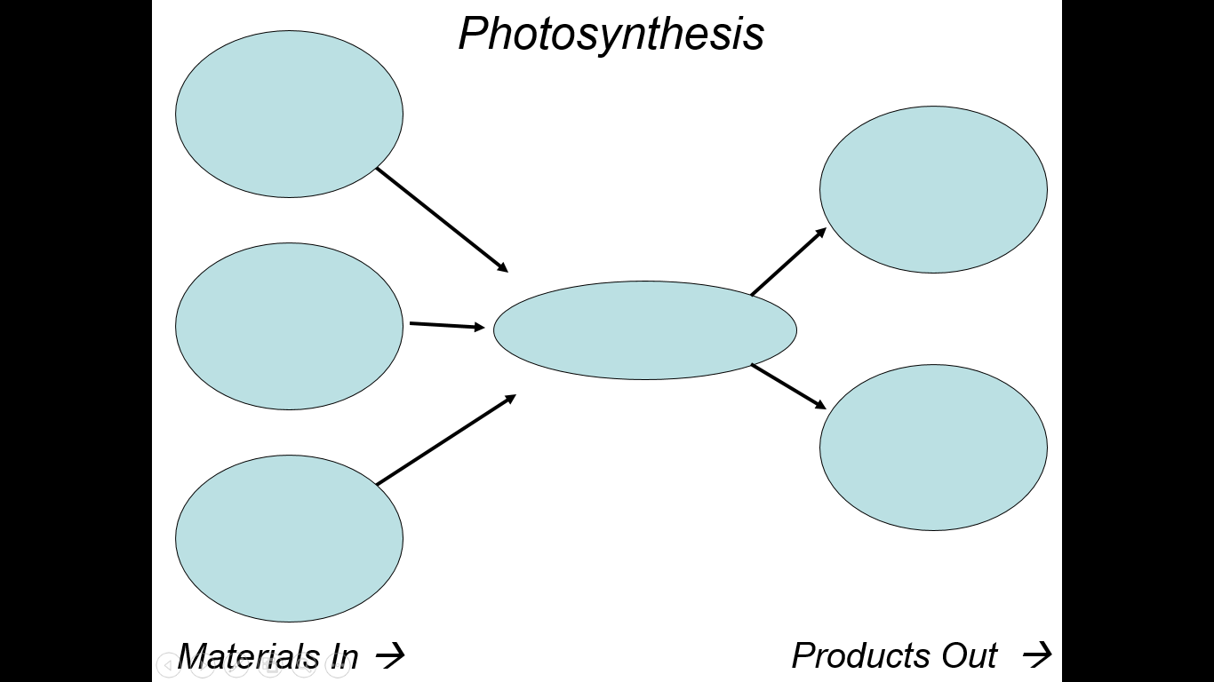
Photosynthesis Guided Notes
Cells Need Energy
- To stay alive, cells need a constant supply of energy. Animals get energy from food, while plant cells get energy from ______________.
- Chemical energy- energy stored in the _______________ between atoms of every molecule
- A major energy source for most cells is stored in a sugar molecule called ______________.
Why do we need energy?
- When you need energy, cells release chemical energy from ___________.
- When you move, muscle cells release chemical energy from glucose (_________________) to move your legs.
- The more you move, the more glucose your muscle cells need. You eat food to restore the glucose supply in muscles. (Remember, glucose is __________!)
- Plants transform the energy in sunlight into the chemical energy in glucose in their ______________.
- _________________- The process that plant cells use to change the energy from sunlight into nutrients for the plant.
- The source of energy for all organisms ultimately comes from the Sun.
- Takes place in the _________________ of plant cells.
- Chloroplasts contain _______________ which traps the sunlight.
How does photosynthesis work?
1. The starting materials: _______________ and ________________
2. The process: Carbon dioxide and water enter the plant cell’s _______________. Meanwhile, __________________ is capturing energy from the sun.
3. The products: Glucose and _______________.

