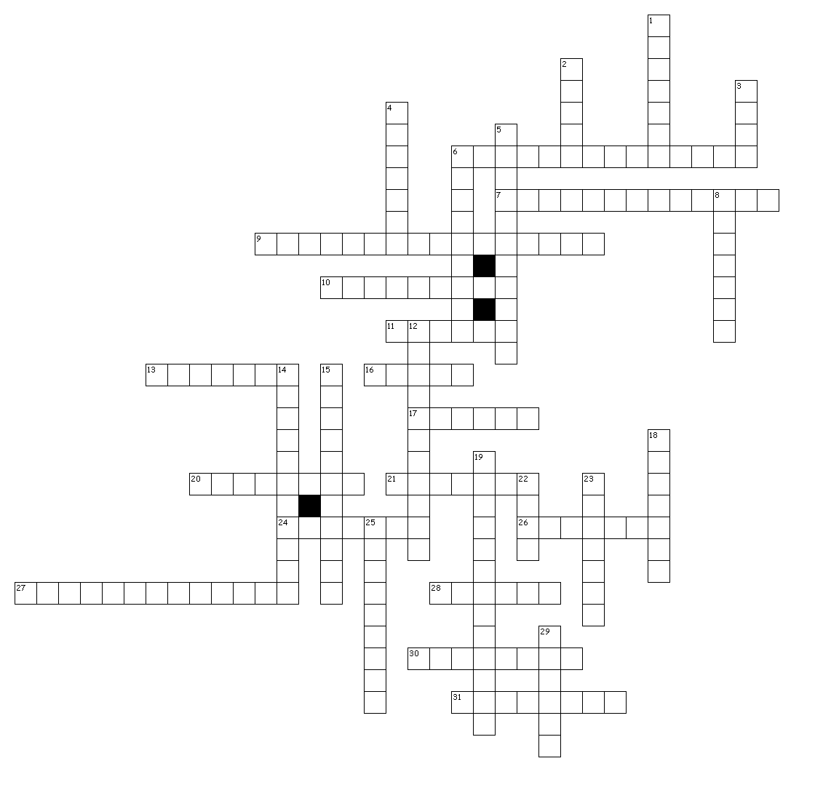
Skeletal, Muscular, Digestive, Respiratory & Excretory (Urinary) Human Body Systems Crossword Puzzle
Across Down
6. Water and remaining nutrients are removed. | 1. Work in pairs; one contracts and the other relaxes
7. Skull | 2. Allows for the absorption of nutrients.
9. Skeletal | 3. Breaks down fat
10. Ribs | 4. Your windpipe.
11. Group of similar cells that serve the same purpose. | 5. Function toward a common purpose
13. Muscle tissue of the heart. | 6. Attach bone to bone.
16. Produces bile | 8. Muscles attach to bone.
17. Organ responsible for speech. | 12. No control of these muscles.
20. Muscle growth. | 14. Support the body
21. Replaces lining every 3 days. | 15. Ability to maintain internal conditions
24. Store urine | 18. Chemical and mechanical
26. One inch thick. | 19. Shoulder
27. Carries air from the trachea to lungs. | 22. Quick muscle contractions produce
28. Filters waste and toxins from urine. | 23. Allows to hold organ closed until urination.
30. Die of starvation without it. | 25. Contracts as your lungs expand.
31. Regulate blood in kidneys. | 29. Spongy bone that produces red blood cells

