Self-Propelled Car Project Due Monday December 7
One or two-person teams will design, construct, and test a car to run faster and farther than the other cars in the class. After you present your car you will get to race your car against your classmates!

Part I- Diagram/Drawing, Write-up: 50 POINTS
Part II- Practice Log: 25 POINTS
Part III- Model Car: 25 POINTS
Total- 100 POINTS (FORMAL ASSESSMENT GRADE)

Part I- Diagram/Drawing and Write-up (50 POINTS):
- Diagram/Drawing: 20 POINTS
  - Diagram or drawing should be:
    - Clearly labeled with all parts used
    - Neat and organized, colored
    - Large enough to fill a sheet of computer paper, and no larger
    - Reflects your best effort
- Write-up:
  - Self-propelled car strategy: 15 POINTS
    - How did you come up with your ideas?
    - How did your ideas change during your project?
    - Why did you choose to use specific parts?
  - Self-propelled car design: 15 POINTS
    - Where is the potential energy stored in your machine?
    - Where are the energy transfers? (List this in steps.)

Part II- Practice Log (25 POINTS):
- You will be given a sheet of graphing paper attached to a Practice Log Table.
- You will run ten practice runs with your car logging distance and time for each run. 5 POINTS
- You will calculate the speed for each run, as well as the average speed overall. 10 POINTS
- You will choose your FIVE top speed trials, and then you will graph each of your five trials’ speeds on your distance-time graph provided. Make sure to use as much of your graph as possible. Make sure you label each trial with a number or color. 10 POINTS

Part III- Model Car (25 POINTS):

Your car will be graded on the following criteria:
- Car moves on its own
- Car is sturdy/structurally sound
- Reflects your best effort
Rules of Competition:
- When placed on the starting line, car must move under its own power and must remain on flat surface (no flying).
- You may not push your car. You will be allowed to hold the car down and let go or release a switch or trigger, but you may never impart a force on the car in the direction of motion.
- The car’s power must ride on the car itself. You may not use a launching device such as a ramp or sling-shot.
- No electrical, chemical, animal, or commercially available motors are allowed.
- No carbon dioxide cartridges, dangerous chemicals, rocket engines, or explosives are allowed.
- No pre-manufactured car bodies may be used.
- No pre-manufactured wheels may be used. (You may not use items for wheels that were pre-manufactured.)
- All contestants must have pretest data results. That is, you must test your final product on your own time a minimum of ten times prior to the final race. Record distance traveled and time; then calculate the average speed. A data table containing this information is due the day of the race (OCT 13).
- Part of the grade in this project comes from the design, solid construction, and beauty of your car. Be creative when you are designing and building your car. Possible propulsion energy sources include a falling weight, a mousetrap, and stretched or twisted elastic materials such as rubbed bands or bungee cords.
Name _____________________________________________________
A few helpful hints:
- Your distance traveled should be measured in cm. Use a ruler and maybe some masking tape to measure off your “drag strip”.
- You should have a partner or a helper to keep your time. You can’t start your car and keep the time at the same time. Your time won’t be accurate!
- Calculate your speed for each trial. Don’t forget the formula for speed! Remember the formula is distance traveled over a period of time, or S = d/t
- Calculate your car’s average speed and fill in the blank below the table. Remember, we calculate averages by adding all values together and dividing by how many values there are!
- Remember to find your top five speeds. List your top 5 speeds below the table.
My Car’s Practice Trial Log
 | Distance traveled (in cm) | Time (in seconds) | Speed  (in cm/s)
Trial 1

Trial 2

Trial 3

Trial 4
Trial 5
Trial 6
Trial 7
Trial 8
Trial 9
Trial 10

My car’s average speed is: ________________________________________
My car’s top five trials are:
Trial Number | Speed
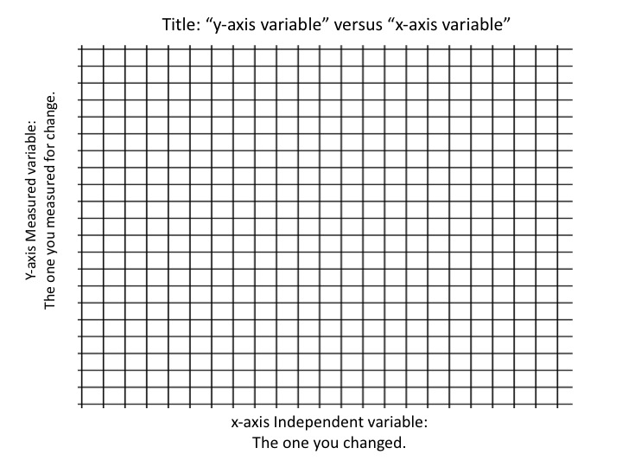
DISTANCE
TIME

